Feedback document Dashboard Milesahead

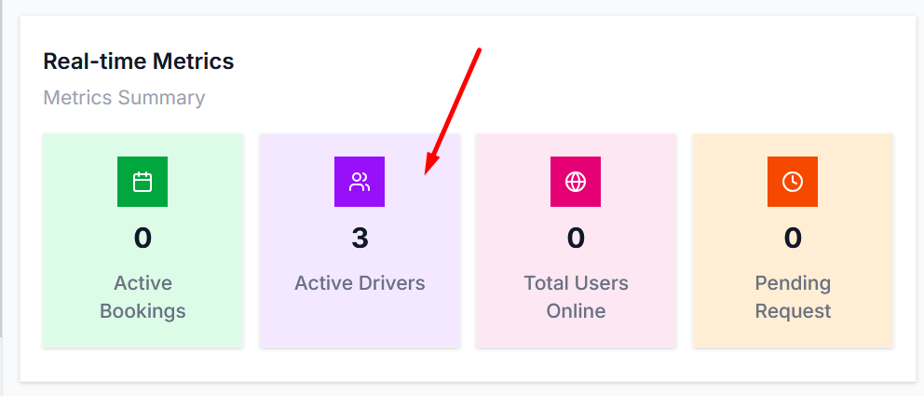

Here we need to mention “Active Cleaners”
2. 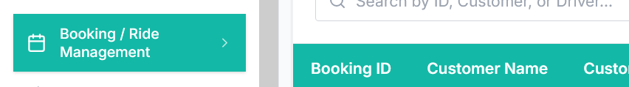

Hide this module

3.
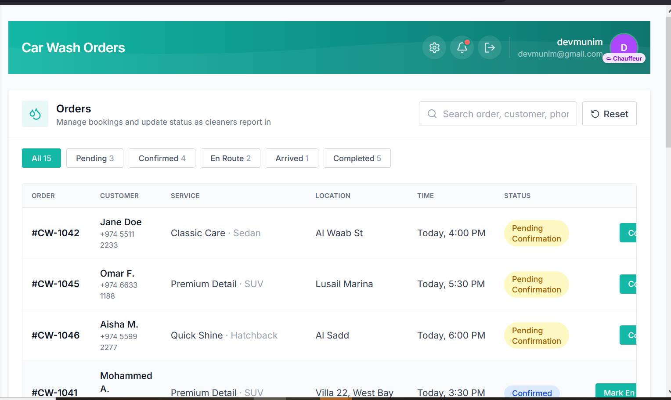

Need to add filters here i.e
- 1. All – 15
- Pending – 3
- Confirmed – 4
- En Route – 2
- Arrived – 1
- Completed – 5
Along with these, there's also a search bar (search by order, customer, phone) and a Reset button, which act as additional filtering/reset controls but aren't status-tab filters themselves.
4. Need ad the functionality like ,, once the cleaner will reach the destination he will call the admin that am at user location then admin will send the notication to user that cleaner is arrived ,,
need 3 push notifications from admin side
1. Cleaner is on the way
2. Cleaner is arrived
3. Job completed (once is done with the clean activity)

